Question 3:

**Solution**

1. Array = { 1,2,3,4,5}, search value = 2
2. 1-2-3-4-5-6-7-9-10-5-6-7-9-11-5-6-7-8-5-12

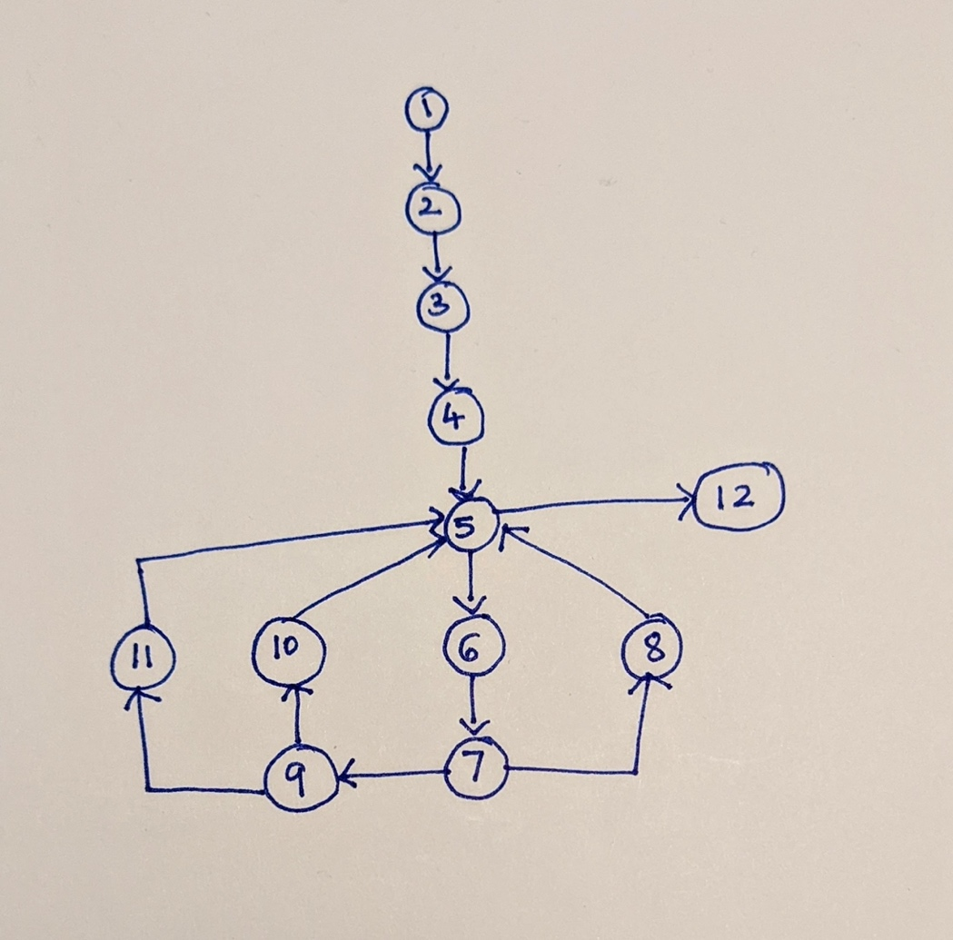

1. e = 14, n = 12, p = 1

V(G) = e-n+p = 14 – 12 + 1 = 3

CV(G) = V(G) + 1 = 3 + 1 = 4

S = { 1-2-3-4-5-12, 5-6-7-8-5, 7-9-10-5, 9-11-5 }

Question 4:

**UNIT TEST**

|  |  |
| --- | --- |
| Section | Description |
| Test Scenario ID | TS1 |
| Test Scenario | Log In |
| Test Case ID | TC1 |
| Test Case | Verify Username |
| Pre-Condition | Login page is up and running |
| Instructions (Steps) | 1. User goes to the login page 2. User gives username = “Archana” 3. User gives password = “” 4. User clicks on the login button |
| Expected output | The system displays “ Please enter your password” |

|  |  |
| --- | --- |
| Section | Description |
| Test Scenario ID | TS1 |
| Test Scenario | Log In |
| Test Case ID | TC2 |
| Test Case | Verify Username |
| Pre-Condition | Login page is up and running |
| Instructions (Steps) | 1. User goes to the login page 2. User gives username = “” 3. User gives password = “123” 4. User clicks on the login button |
| Expected output | The system displays “ Please enter your username” |

|  |  |
| --- | --- |
| Section | Description |
| Test Scenario ID | TS1 |
| Test Scenario | Log In |
| Test Case ID | TC2 |
| Test Case | Verify Username |
| Pre-Condition | Login page is up and running |
| Instructions (Steps) | 1. User goes to the login page 2. User gives username = “Archana” 3. User gives password = “” 4. User clicks on the login button |
| Expected output | The system displays “ Please enter your password” |

**Integration Test**

|  |  |
| --- | --- |
| Section | Description |
| Test Scenario ID | TS1 |
| Test Scenario | Log In |
| Test Case ID | TC3 |
| Test Case | User Authentication |
| Pre-Condition | The login page is up and running |
| Instructions (Steps) | 1. User gives a valid username = “Ana” and invalid password = “12” 2. User clicks on the login button 3. System verifies the username on the database but cannot verify the password given |
| Expected output | The system should display “Invalid username or password” |

**System Test**

|  |  |
| --- | --- |
| Section | Description |
| Test Scenario ID | TS2 |
| Test Scenario | Transfer Funds |
| Test Case ID | TC4 |
| Test Case | Verify Transfer |
| Pre-Condition | The user logged and has the available balance |
| Instructions (Steps) | 1. User gives a valid destination account = “Zack” 2. User gives a valid amount to be transferred 3. User clicks on the transfer button 4. System verifies that the destination account is valid 5. System verifies that the user has sufficient funds for the transfer 6. System makes the transfer |
| Expected output | The system should display “Transfer is successful” |